**Networking Lab**

**Lab Assignment No. 2**

Name: Sreekesh Iyer Class/Roll No. D10A/24

**Aim:** Installing NS2 in a Linux Machine.

**Theory:**

Ns is a discrete event simulator targeted at networking research. Ns provides substantial support for simulation of TCP, routing, and multicast protocols over wired and wireless (local and satellite) networks.  
  
To install NS2 using the Linux command line, you’ll be needing gcc and g++ compilers. The latest versions of Linux are shipped with the latest versions (9.3 as of now) of these compilers. However, NS2 (perhaps due to the old source code) needs gcc and g++ version 4.8 to successfully install it. Hence, we have to install gcc-4.8 and g++-4.8 to get this installation working.  
  
Steps to downgrade gcc and g++:

1. Use the following code to remove the current version of gcc and g++.  
     
   $ sudo apt purge gcc  
   $ sudo apt-get autoremove
2. Edit the source file and get it to download older dependencies of gcc and g++.  
     
   $ sudo gedit /etc/apt/sources.list
3. Add the line: “deb <http://in.archive.ubuntu.com/ubuntu> bionic main universe” to this file at the end.  
   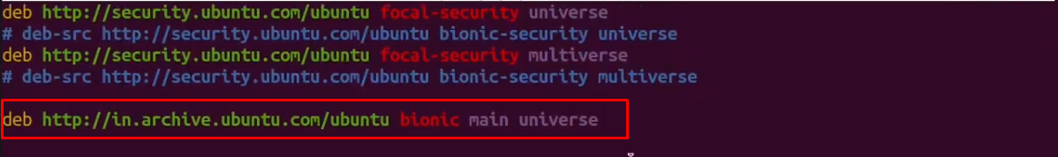
4. Now update again and you’ll notice that older versions of gcc and g++ are getting downloaded. Then install gcc and g++  
     
   $ sudo apt update  
   $ sudo apt install gcc-4.8 g++-4.8  
     
   

Now that our gcc and g++ compilers are downgraded, we can proceed to install ns2, but before that, we also need to make certain changes in Makefile files and manually add the compiler versions.

**Steps to Install NS2:**

1. Download the ns2 zip file in your Linux download directory from the link - <https://sourceforge.net/projects/nsnam/files/latest/download>  
   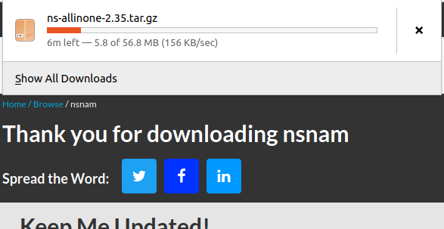
2. Use the tar command to unzip the files.  
     
   $ tar zxvf ns-allinone-2.35.tar.gz  
     
   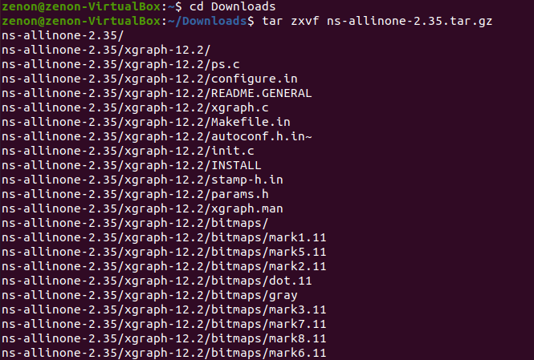
3. Open the file *ns-2.35/linkstate/ls.h* and make changes in line 137 in the eraseAll function. Change the erase call to a constructor call by adding “this->” to the line.   
   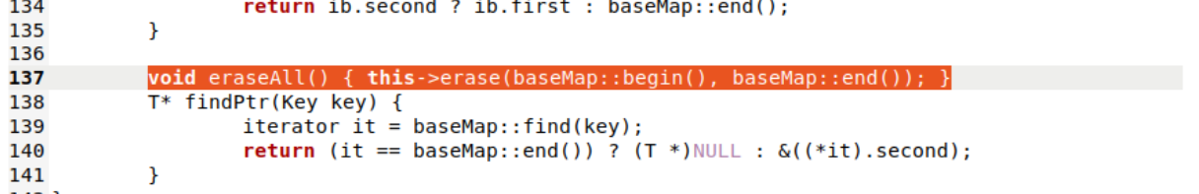
4. Now replace @CC@ and @CPP@ with gcc-4.8 and g++-4.8 respectively in files *otcl-1.14/Makefile.in*,   
   *ns-2.35/Makefile.in*,   
   *nam-1.15/Makefile.in* and  
   *xgraph-12.2/Makefile.in*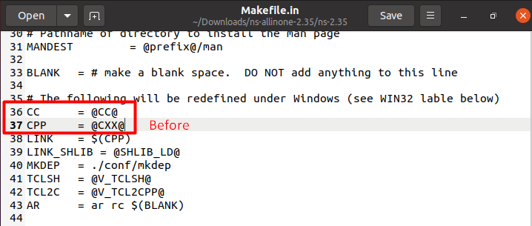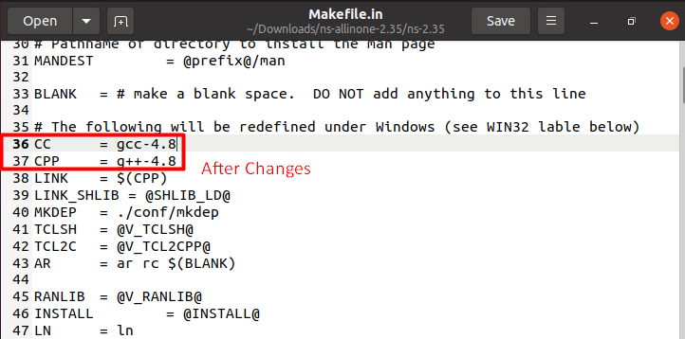
5. After making changes to the files, we can proceed with installing ns2. Change command line directory to Downloads/ns-allinone-2.35/  
   Use the code:   
     
   $ ./install  
   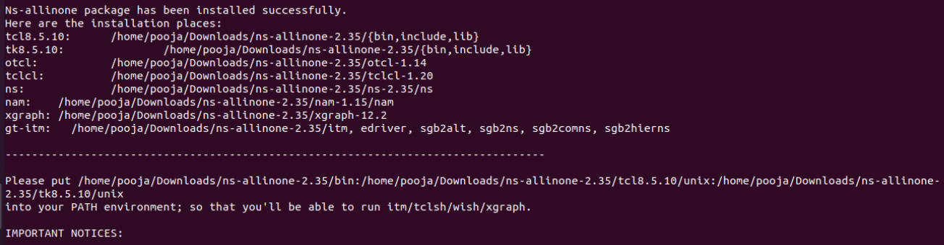
6. You’ll get a successfully installed message once completed. After that, we need to make changes to the PATH. Open up a new Terminal and write the code:  
     
   $ sudo gedit .bashrc.  
     
     
   Paste the following lines:  
   export PATH=$PATH:/home/<yourusername>/ns-allinone-2.35/bin:/home/<yourusername>/ns-allinone-2.35/tcl8.5.10/unix:/home/<yourusername>/ns-allinone-2.35/tk8.5.10/unix

export LD_LIBRARY_PATH=/home/<yourusername>/ns-allinone-2.35/otcl-1.14:/home/<yourusername>/ns-allinone-2.35/lib  
  
Replace <yourusername> with the display name.  
  
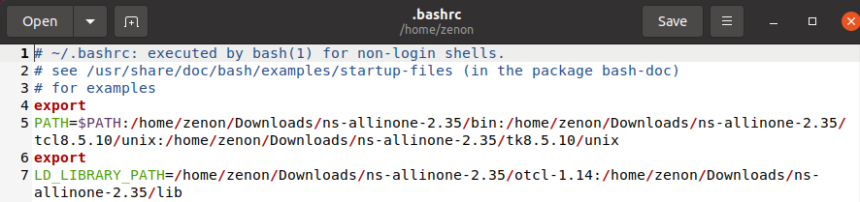

1. Save the file and write the following code in the command line.  
     
   $source .bashrc
2. Now, install the latest version of tclsh to get the ns shell working.   
     
   $sudo apt install tclsh
3. You can type *ns* in the command line to confirm you have successfully installed it.   
   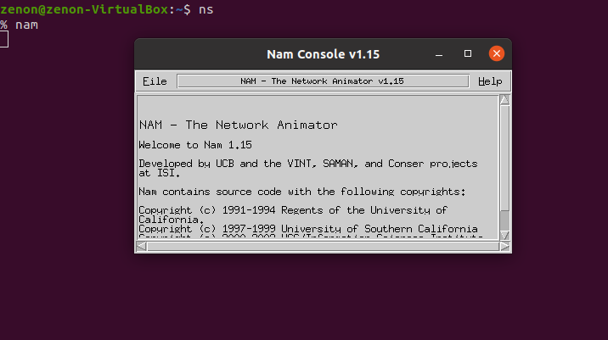

**Conclusion:** NS2 is successfully installed on our Linux machine.